Day 9 Assignment -MRF function

1.Solving problems using array functions on rest countries data.

a. Get all the countries from Asia continent /region using Filter function

Ans

const url ="https://raw.githubusercontent.com/rvsp/restcountries-json-data/master/res-countries.json";

const fetchdata= async () => {

try{

    const response = await fetch(url);

    const countries = await response.json();

let out = countries.filter((e) =>e.region=="Asia");

let outname=out.map((e)=>console.log(e.name));

}

catch (err){

    console.log(err);

}

};

fetchdata();

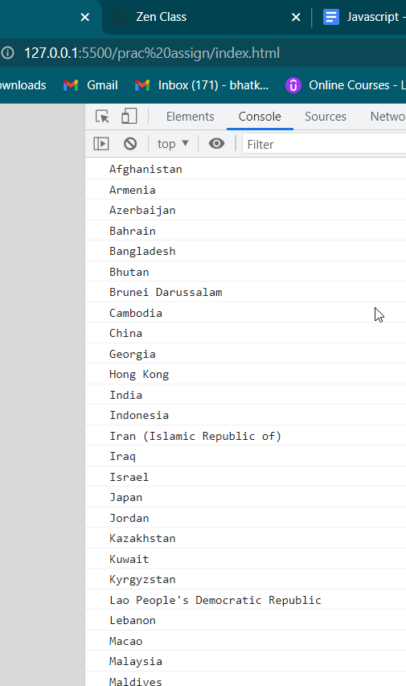

B Get all the countries with a population of less than 2 lakhs using Filter function

Ans;

const url ="https://raw.githubusercontent.com/rvsp/restcountries-json-data/master/res-countries.json";

const fetchdata= async () => {

try{

    const response = await fetch(url);

    const countries = await response.json();

let out = countries.filter((e) =>e.population<=200000);

let outname=out.map((e)=>console.log(e.name));

}

catch (err){

    console.log(err);

}

};

fetchdata();

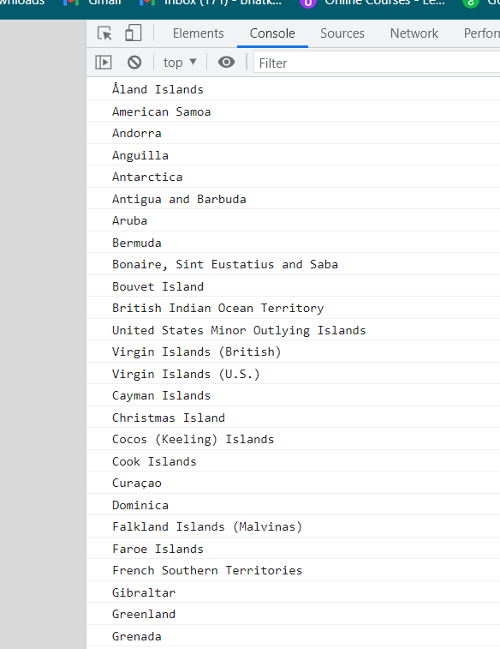

1. Print the following details name, capital, flag using forEach function

Ans;

const url ="https://raw.githubusercontent.com/rvsp/restcountries-json-data/master/res-countries.json";

const fetchdata= async () => {

try{

    const response = await fetch(url);

    const countries = await response.json();

countries.forEach(element => {

console.log(`

 Name : ${element.name}

 Capital : ${element.capital}

 Flag : ${element.flag}`);

});

}

catch (err){

    console.log(err);

}

};

fetchdata();

Ans;

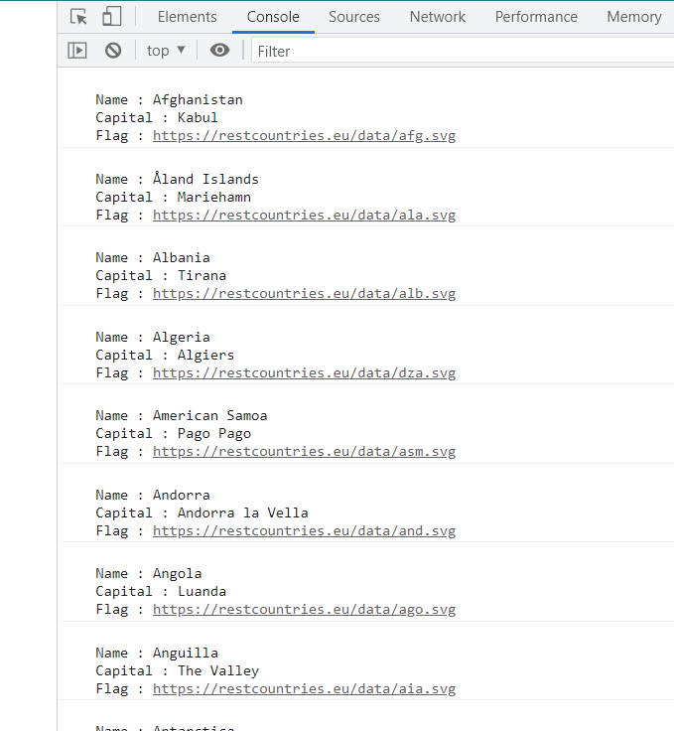

1. Print the total population of countries using reduce function

const url ="https://raw.githubusercontent.com/rvsp/restcountries-json-data/master/res-countries.json";

const fetchdata= async () => {

try{

    const response = await fetch(url);

    const countries = await response.json();

let out = countries.reduce(function(sum,cur){

sum += cur.population;

return sum;

},0);

console.log(out);

}

catch (err){

    console.log(err);

}

};

fetchdata();

ans;

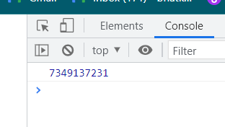

E .Print the country which uses US Dollars as currency.

1. const url ="https://raw.githubusercontent.com/rvsp/restcountries-json-data/master/res-countries.json";
2. const fetchdata= async () => {
3. try{
4. const response = await fetch(url);
5. const countries = await response.json();
6. let out = countries.filter((e) =>e.currencies[0].code == "USD");
7. let outname=out.map((e)=>console.log(e.name));
8. }
9. catch (err){
10. console.log(err);
11. }
12. };
13. fetchdata();

ans;